31. The bulk modulus for an incompressible liquid is
(a) Zero
(b) unity
(c) infinity
(d) between 0 and 1

32. An egg when placed in ordinary water sinks but floats when placed in brine .This is because
(a) density of brine is less than that of ordinary water
(b) density of brine is equal than that of ordinary water
(c) density of brine is greater than that of ordinary water
(d) none of these

33. Pressure at a point inside a liquid does not depend on
(a) the depth of the point below the surface of the liquid
(b) the nature of the liquid
(c) the acceleration due to gravity at that point
(d) the shape of the containing vessel

34. A water tank of height 10 m ,completely filled with water is placed on a level ground.It has two holes one at 3m and the other at 7 m from its base.The water ejecting from
(a) both the holes will fall at the same point
(b) upper hole will fall farther than that from the lower hole
(c) upper hole will fall closer than that from the lower hole
(d) more information required

35. Why the needle of iron swims on Water surface when it is kept gently ?
(a) It will remain under the water when it will displace more water than its weight
(b) the density of needle is less than that of water
(c) due to surface tension
(d) due to its shape

36. A boat will submerge when it displaces water equal to its own
(a) volume
(b) weight
(c) surface area
(d) density

37. Which of the following is most elastic?
(a) Rubber
(b) Wet clay
(c) Steel
(d) Plastic

38. The surface tension of water on adding detergent to it
(a) increases
(b) decreases
(c) no change
(d) becomes zero

39. The hair of shaving brush clings together when removed from water due to—
(a) surface tension
(b) viscosity
(c) elasticity
(d) friction

40. If the diameter of a capillary is doubled, then the rise of water in it will be—
(a) two times
(b) half
(c) four times
(d) no change

41. The main power supply in india is at 220 V ,whereas that in the US is at 110 V .Which among the following statement is correct
- 110 V is safer but more expensive to maintain
- 110 V is safer but more cheaper to maintain
- 110 V leads to lower power loss
- 110 works better at higher latitudes
42. The resistance of a wire of length l and area of cross section a is x ohm.If the wire is stretched to double its length ,its resistance would become
- 2x ohm
- 0.5xohm
- 4xohm
- 6xohm
43. An electric bulb is rated 220 V and 100 W. When it is operated on 110 V, the power consumed will be:
(a) 100 W
(b) 75 W
(c) 50 W
(d) 25 W

44. Find the current flowing through 6 Ω .

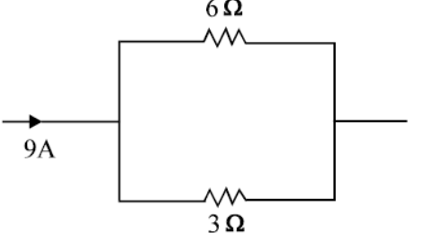
- 3 Α
- 6 Α
- 9 Α
- 12Α
45. If the current I through a resistor is increased by 100% the increased in power dissipation will be (assume temperature remain unchanged)
(a) 100%
(b) 200%
(c) 300%
(d) 400%
46. Three bulbs of 40W,60 W and 100W are connected in series to a current source of 200V.Which of the following statement is true
(a) 40 W bulb glows brightest
(b) 60 W bulb glows brightest
(c) 100 W bulb glows brightest
(d) All bulbs glows with same brightness

47. Kilowatt-hour is unit of
(a) potential difference
(b) electric power
(c) electric energy
(d) charge

48. SONAR is mostly used by
(a) doctors
(b) Engineers
(c) astronauts
(d) navigators

49. Loudness of the sound is related to its
(a) frequency
(b) Amplitude
(c) speed
(d) Pitch

50. Ultrasonic waves of frequency 3X10⁵ Hz are passed through a medium, where speed of sound is 10 times that of air(speed of sound in air is 300 m/s).The wavelength of this wave in that medium will be of the order
(a) 1cm
(b) 10 cm
(c) 100cm
(d) 0.1 cm

Q31 | Q32 | Q33 | Q34 | Q35
C | C | D | C | C
Q36 | Q37 | Q38 | Q39 | Q40
B | C | B | A | B
Q41 | Q42 | Q43 | Q44 | Q45
A | C | D | A | C
Q46 | Q47 | Q48 | Q49 | Q50
A | C | D | B | A

